# Executive Summary - Sensible

Sunday 19th September – Sunday 26th September.

This week we received our approved application, corrected problems among the GPS sensors, finalised our testing report and have finally got our prototype new graph working.

**Rundown of the changes completed:**

- Application for ethical testing approved!

- GPS sensor fixed all issues

- Added indicators for camera and microphone

- Added delete button for recordings (which doesn’t yet delete the files)

- APK and IPA generated

- Sensor testing finalised

- Prototype graph complete

**To be completed next week:**

- Export specific files implemented

- Work on promotional video

- Fix camera issues on iOS

- Implement delete button

- Migrate the project into a form that allows for the prototype graph to be implemented

- UI change to recording indicators

- Find guide sample rates

- Export metadata for recording files

- Start writing handover documentation

- UI changes to labels

**Burndown Chart**

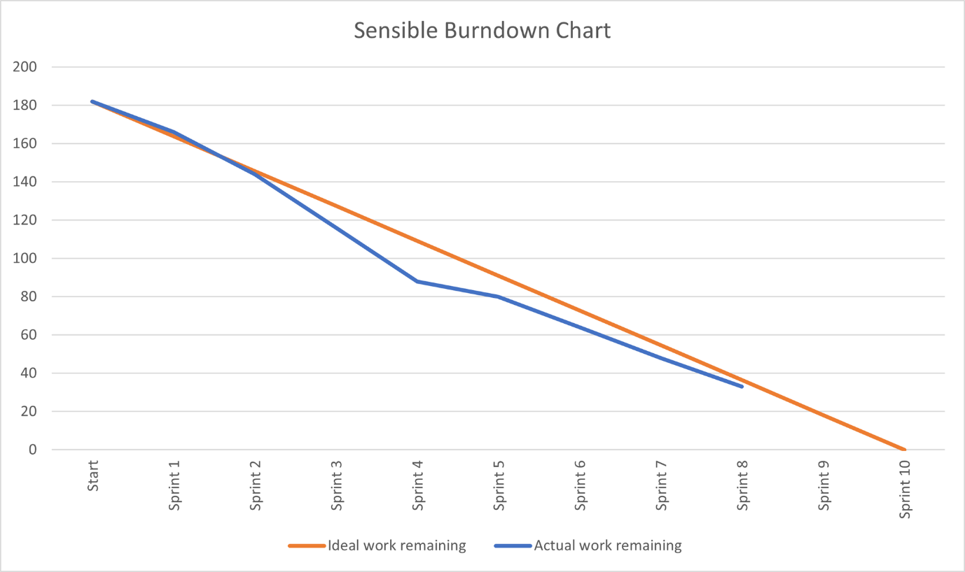

**Not entering letters in sample rates**

**Rounding errors? Y values are the same? (when still)**